SIT 210
Embedded System
Task 2.1P
Summary
Webhooks are used to send data from one system to another automatically when an event happens. In this task the Arduino collects temperature and light sensor readings and sends them to ThingSpeak through the internet. The webhook process works by making an HTTP request to a web service which then receives and stores the data. Webhooks are useful because they allow devices to share information without needing someone to manually send it.
Webhooks are used in many real world applications such as smart homes weather monitoring systems security alerts and IoT devices. In my code the part that sends sensor data to the web is the ThingSpeak function that writes data to the channel fields. The code uses the API key and sends the temperature and light values to ThingSpeak every 30 seconds. This follows the normal webhook mechanism because the sensor readings are collected by the Arduino and then sent through an HTTP request to an online platform where the data can be viewed later.

ThingSpeak
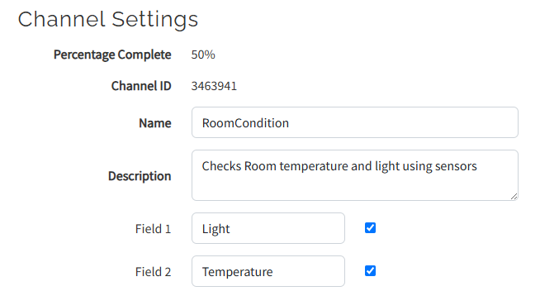
Github link: https://github.com/akashapple1107-rgb/Embeded-System
Graph
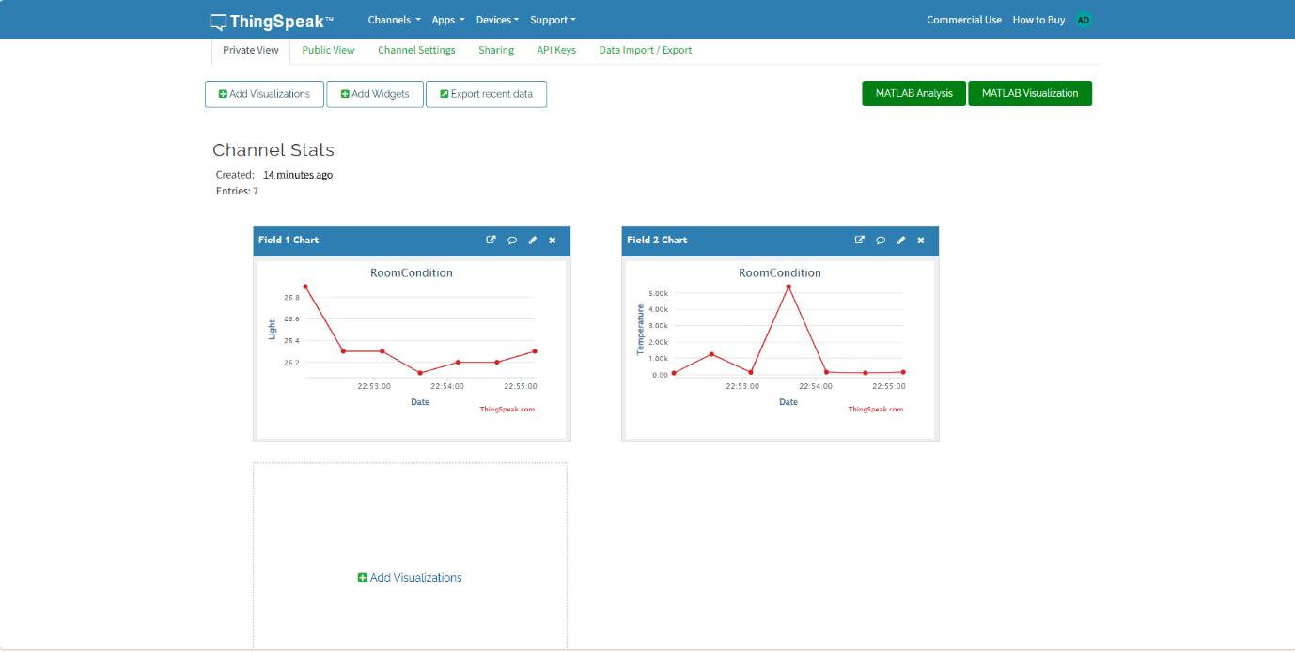
I used a A/C to decrease the temperature around the DHT22 sensor and a flashlight to change the light level detected by BH1750 sensor. This helped me to create changes in the sensor readings and and then observed how the values changed on ThingSpeak.
Circuit
